William Faunce

Carol Roberts

COS 225

20 April 2018

A9WilliamFaunce

Part I

* 1. 10 15 30 35 40 20 25 45 50
  2. 50 40 30 10 15 35 45 20 25
  3. 10 30 15 40 35 50 20 45 25

|  |  |  |  |  |  |  |
| --- | --- | --- | --- | --- | --- | --- |
| 90 | 70 | 80 | 10 | 30 | 50 | 40 |

* 1. A

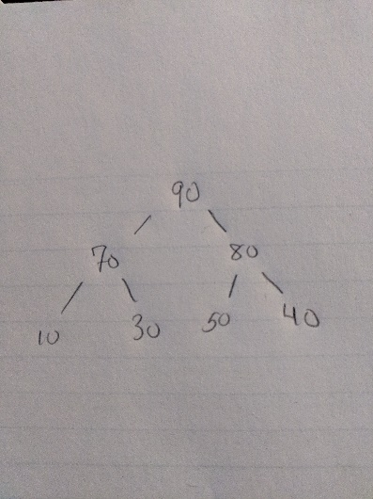

|  |  |  |  |  |  |  |
| --- | --- | --- | --- | --- | --- | --- |
| 90 | 70 | 80 | 30 | 40 | 50 |  |

* 1. A

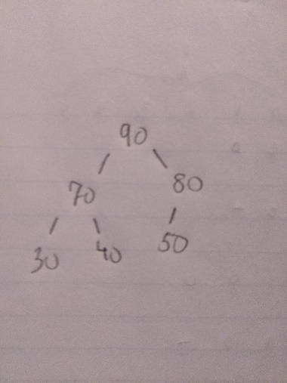

Screenshots:

